How does AdaBoost work

Let’s assume that this is our dataset:
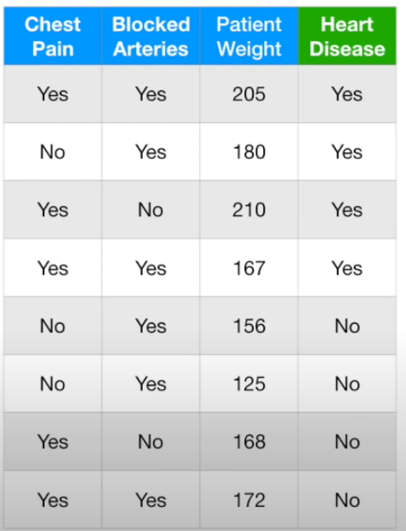

At first we assign a weight to each sample:
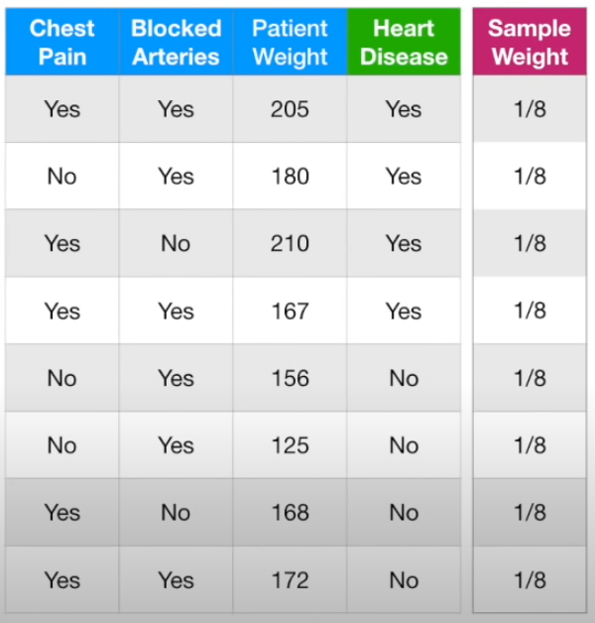

Where each weight = 1 / number of samples. Now we create a stump (a decision tree with just one node). We create it just like a root node for a normal decision tree:
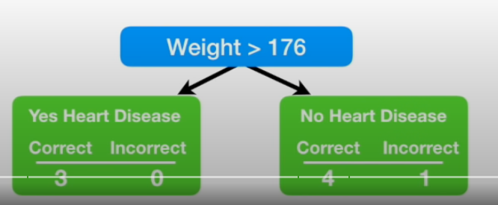

Then we identify for which sample this stump has made incorrect classification:
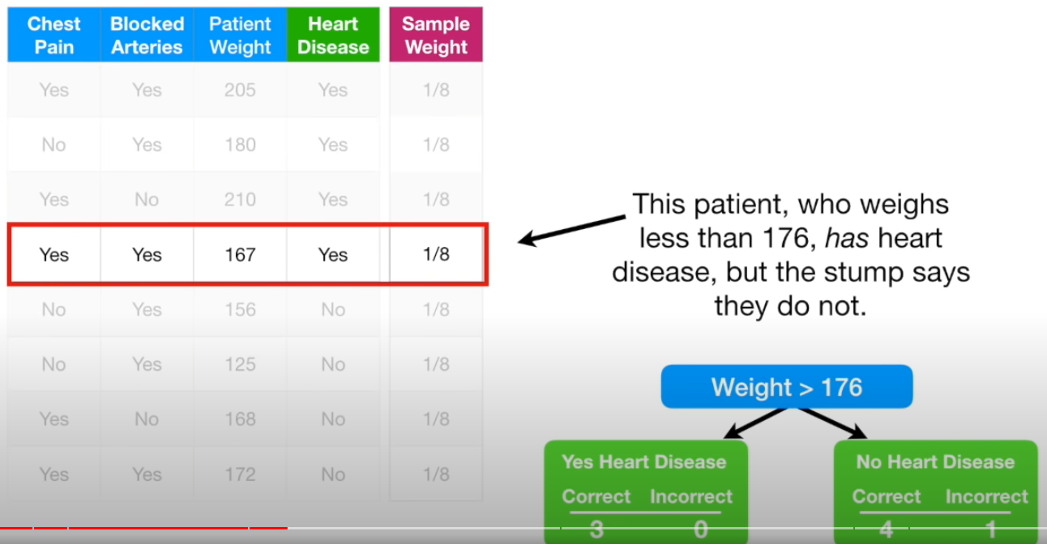

Then we calculate a total error for that stump. It is a sum of weights associated with incorrectly classified samples. In this case it is 1/8.

Now we will calculate the ‘Amount of Say’ value which indicates how important are predictions of that stump. How much it has to say. We are using this formula:
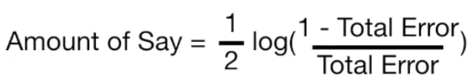

And this graph shows dependency between the Amount of Say and Total Error:
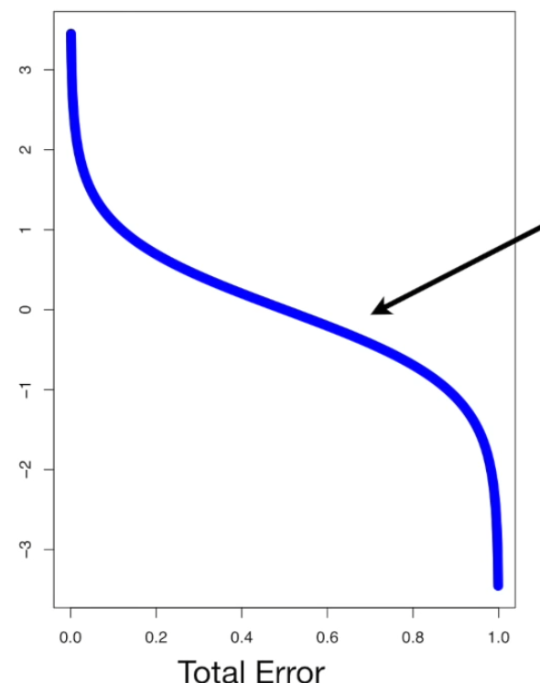

Now we will increase a sample weight for the sample, for which our stump has made an incorrect classification using this formula:
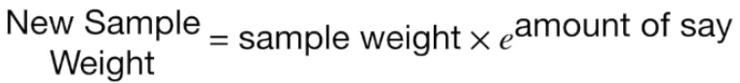

For all the other samples, for which our stump has correctly classified we decrease a sample weight by using this formula:
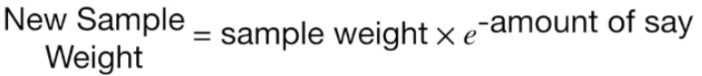

Now we normalize all the sample weights such that they all sum up to 1.

Now we can use those new sample weights to create another stump. In this way we are forcing the new stump to put more focus on correctly classifying those samples which were incorrectly classified by the previous stump.

To create a new stump we can calculate the weighted gini indexes for the rest of columns or we can create a new dataset. In order to create this new dataset, at first we select a random number between 0 and 1 and we select a row corresponding to that number. If our weights looks like this:
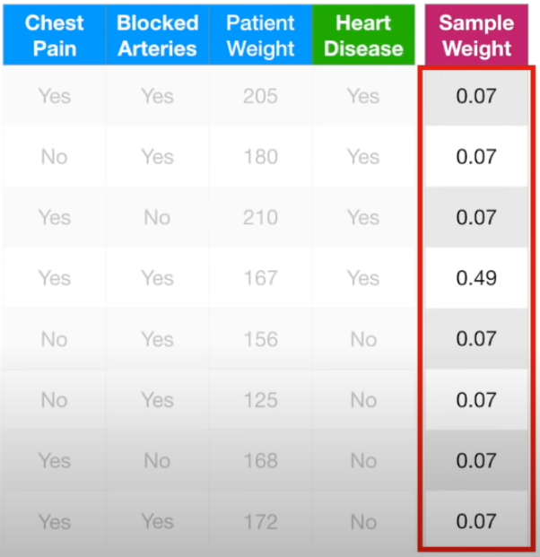

And we selected a number between 0 and 0.07, then corresponding row will be the first one. If we selected a number between 0.07 and 0.14 then corresponding row will be the second one. If we selected a number between 0.21 and 0.7 (0.21 + 0.49 = 0.7) then corresponding row will be the fourth one.

So in the new dataset we can have some rows duplicated. The row with the highest weight will have the most duplicates because it will be choosen the most often.

Because in the new dataset the row with the highest sample weight will have the most duplicates it will force the algorithm to create a new stump such that it correctly classifies this sample.

How to make predictions

Once we created all of the stumps and we want to make predictions

